Hello....
I am providing information pertaining to the upcoming Vendor Conference for RFP 4133. This information will also be posted on our website along with the originating RFP document.

A vendor conference will be held on Friday, December 6, 2024 at 2 p.m. virtually and in person to respond to written questions and to provide any needed additional instruction to vendors on the submission of proposals.

If attending virtually:
Vendor conference
Friday, December 6 · 2:00 – 3:00pm
Time zone: America/Chicago
Google Meet joining info
Video call link: https://meet.google.com/bbr-jmhm-jcy
Or dial: (US) +1 318-526-1513‬ PIN: 397 035 399‬#
More phone numbers: https://tel.meet/bbr-jmhm-jcy?pin=6202167362880

If attending in person:
Room 103 at the Doyle Building, 545 W. Dayton St., Madison, WI 53703.
- Park in the parking lot next to the Doyle building. Only use the stalls with blue lines.
- Go to the entrance and buzz the button. Let them know you are here for a vendor conference with Communications.
- Once they let you in, go to Human Resources (first office to your right), sign in and get a parking permit.
- Place the parking permit on your vehicles dashboard.
- Go back to Human Resources and ask them to let Edell Fiedler know you are here. She or a team member will come get you and bring you to the room.

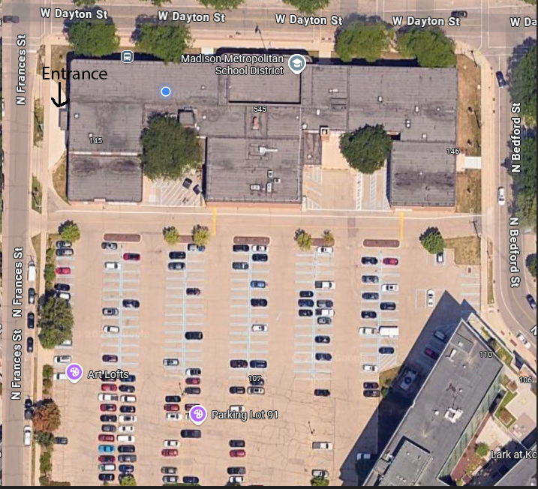

REMINDER:
I need to stress the following information: This RFP is issued by Madison Metropolitan School District, Purchasing Services, which is the sole point of contact for the District during the Request for Proposal and Response process. Dana Scheel and/or Chris Wayland (Purchasing Services) are responsible for managing the procurement process. With the exception of matters pertaining specifically to the logistics of the Vendor Conference and information pertaining specifically to this invitation, you should not have contact with anyone else specifically pertaining to this opportunity during the process.

